ARDUINO

Aluno: Webster Santos

RM: 169086

EXERCÍCIO 1

// C++ code

//

void setup()

{

pinMode(10, OUTPUT);

pinMode(9, OUTPUT);

pinMode(5, OUTPUT);

pinMode(4, OUTPUT);

pinMode(3, OUTPUT);

pinMode(LED_BUILTIN, OUTPUT);

digitalWrite(3, LOW);//RED CAR

digitalWrite(4, LOW);//YELOW CAR

digitalWrite(5, LOW);//GREEN CAR

digitalWrite(10 , LOW);//RED PEDESTRIAN

digitalWrite(9, LOW);//GREEN PEDESTRIAN

digitalWrite(10, HIGH);

digitalWrite(9, LOW);

digitalWrite(5, LOW);

digitalWrite(4, LOW);

digitalWrite(3, HIGH);

}

void loop()

{

digitalWrite(10, HIGH);

digitalWrite(3, HIGH);

digitalWrite(5, LOW);

delay(5000);

digitalWrite(4, HIGH);

digitalWrite(3, LOW);

delay(2000);

digitalWrite(4, LOW);

digitalWrite(5, HIGH);

digitalWrite(9, HIGH);

digitalWrite(10, LOW);

delay(6000);

digitalWrite(9, LOW);

digitalWrite(10, HIGH);

delay(500);

digitalWrite(10, LOW);

delay(500);

digitalWrite(10, HIGH);

delay(500);

digitalWrite(10, LOW);

delay(500);

}

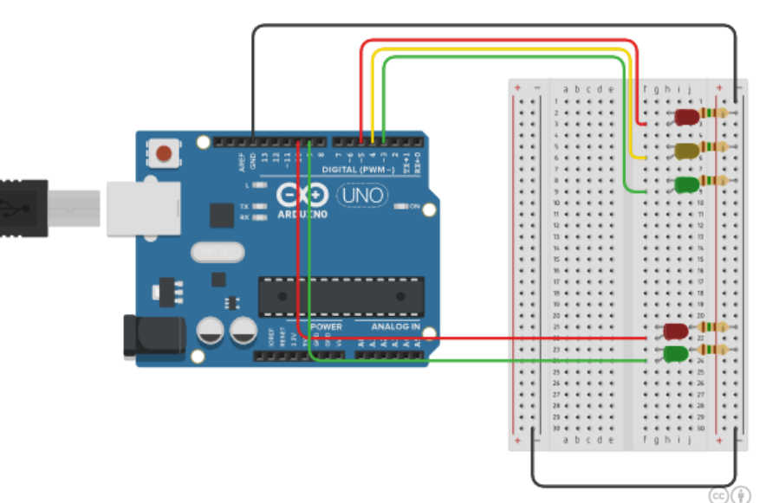

EXERCÍCIO 2

// C++ code

//

void setup()

{

pinMode(10, OUTPUT);

pinMode(9, OUTPUT);

pinMode(5, OUTPUT);

pinMode(4, OUTPUT);

pinMode(3, OUTPUT);

pinMode(6, OUTPUT);

pinMode(7, OUTPUT);

pinMode(8, OUTPUT);

pinMode(LED_BUILTIN, OUTPUT);

digitalWrite(3, LOW);//RED CAR

digitalWrite(4, LOW);//YELOW CAR

digitalWrite(5, LOW);//GREEN CAR

digitalWrite(10 , LOW);//RED PEDESTRIAN

digitalWrite(9, LOW);//GREEN PEDESTRIAN

digitalWrite(6, LOW);//GREEN CAR 2

digitalWrite(7, LOW);//YELOW CAR 2

digitalWrite(8, LOW);//RED CAR 2

digitalWrite(10, HIGH);

digitalWrite(9, LOW);

digitalWrite(5, LOW);

digitalWrite(4, LOW);

digitalWrite(3, HIGH);

}

void loop()

{

digitalWrite(10, HIGH);

digitalWrite(3, HIGH);

digitalWrite(5, LOW);

digitalWrite(8, HIGH);

delay(5000);

digitalWrite(4, HIGH);

digitalWrite(3, LOW);

delay(2000);

digitalWrite(4, LOW);

digitalWrite(5, HIGH);

digitalWrite(6, HIGH);

digitalWrite(8, LOW);

delay(5000);

digitalWrite(8, LOW);

digitalWrite(7, HIGH);

digitalWrite(6, LOW);

delay(2000);

digitalWrite(7, LOW);

digitalWrite(8, HIGH);

digitalWrite(9, HIGH);

digitalWrite(10, LOW);

delay(4000);

digitalWrite(9, LOW);

digitalWrite(10, HIGH);

delay(500);

digitalWrite(10, LOW);

delay(500);

digitalWrite(10, HIGH);

delay(500);

digitalWrite(10, LOW);

delay(500);

}

